# Kibana sdki-rooms:

<https://kibana.us1.eak.twilio.com/video/goto/9010d5011cb857ba69b9df43ac7cc221>

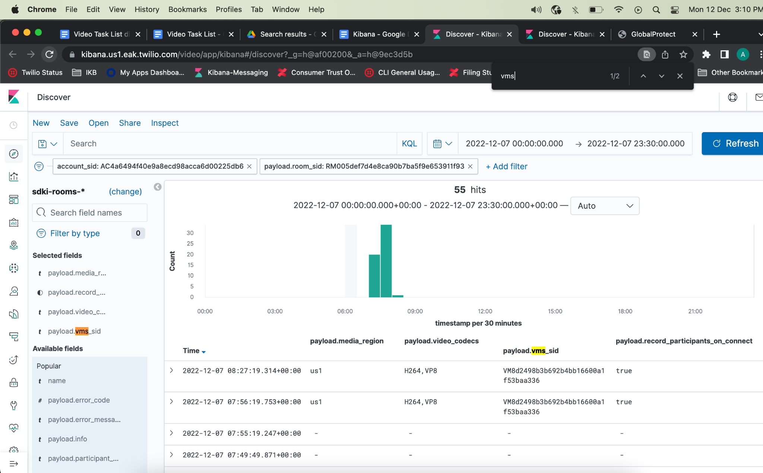

# **Kibana video-insights:** <https://kibana.us1.eak.twilio.com/video/goto/75fa1ae426098ea020f2c72a642ce6bb>

# Kibana video-vms-reports*:

<https://kibana.us1.eak.twilio.com/video/goto/613bc084c0164849e62fc5810d0a6461>

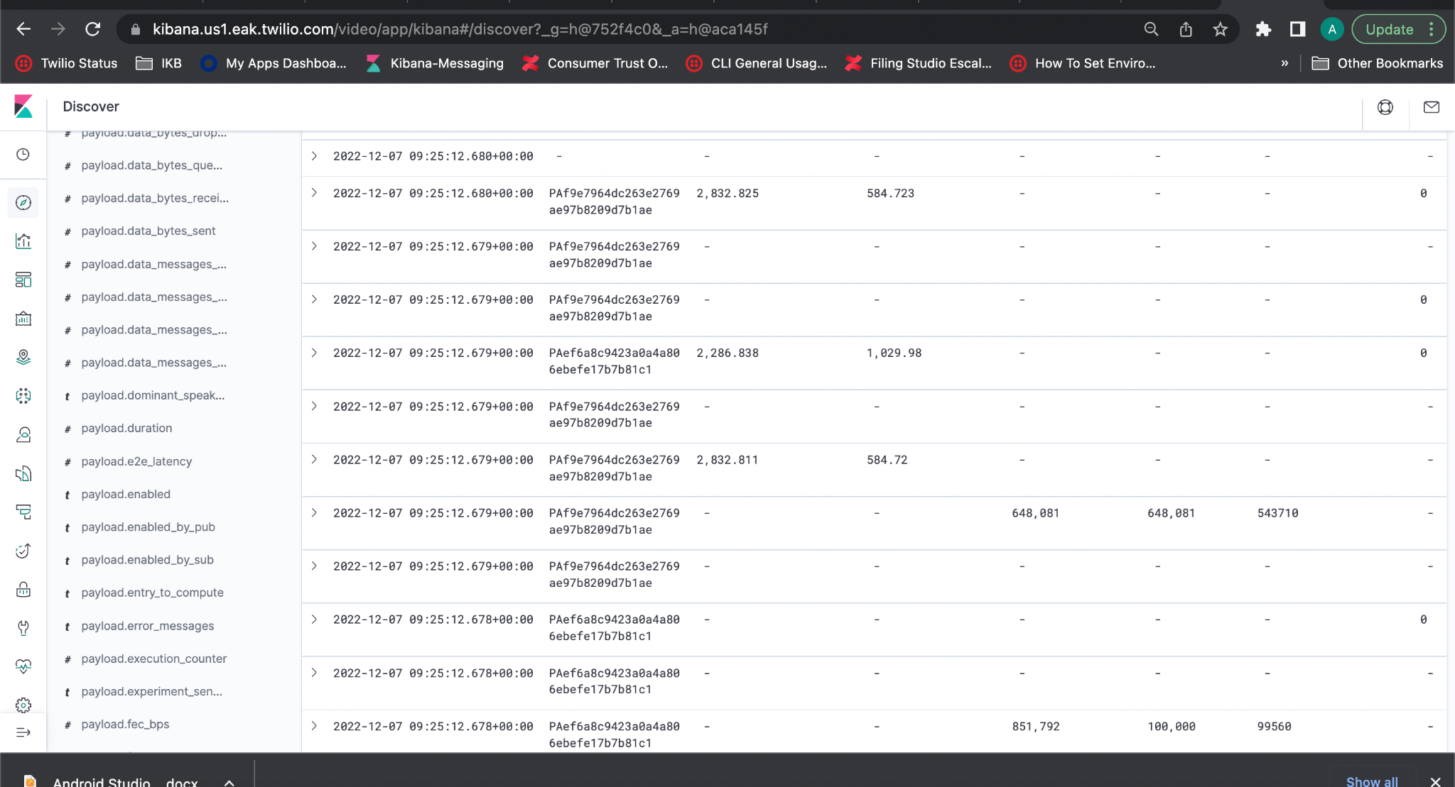

# Kibana video-voice-signaling*:

<https://kibana.us1.eak.twilio.com/video/goto/370c12b2b906ecc16755a2a2ec9567b4>

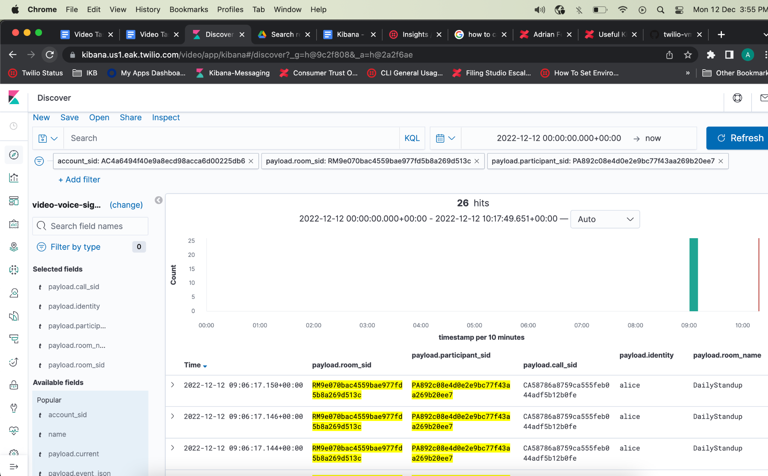

# Kibana Network Quality Level-*

<https://kibana.us1.eak.twilio.com/video/goto/457da82ec7e52eadeeaa17ae9e21ca54>

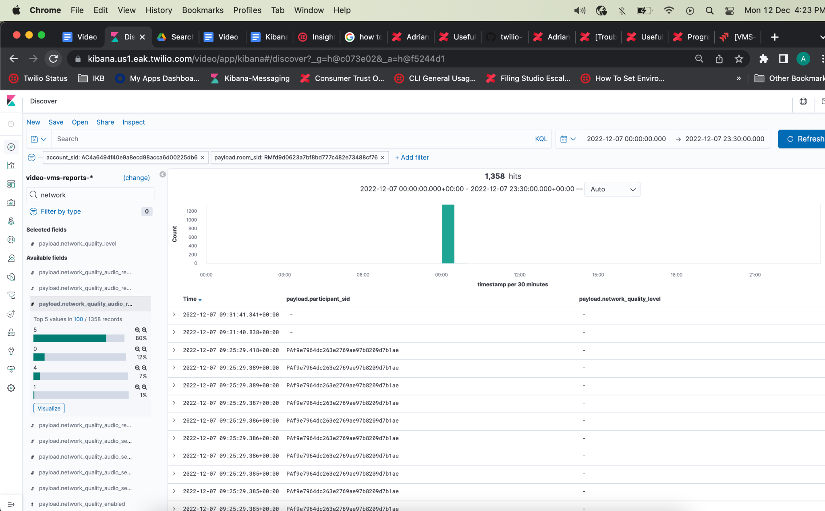

# Visualization:Kibana Network Quality Level-*

<https://kibana.us1.eak.twilio.com/video/goto/b9da76b09fc0c4836e4772e3c9e8f913>

